Imperial College London

EERover Report

Team Crater

Subhakrish Krishnamra (01178592)

Sung Hoon Jang (01235916)

Prithvi Menon (01204587)

Yasmin Baba (01196634)

Pedro Monteiro (01209405)

Kaiyue Sun (01197813)

Word Count: 7865

Himadri Das and Esther Perea

March 24th 2017

**Contents**

**Part 1**

1. **Introduction**…………………………………………………………………….4

1.1 Technical Problem……………………………………………………………..4

1.2 Main Points of PDS……………………………………………………………4

1.3 High Level Design…………………………………………………………….5

1. **Design Process**…………………………………………………………………8

2.1 Concept Generation…………………………………………………………...8

2.2 Concept Selection……………………………………………………………..9

2.3 Simulations……………………………………………………………………13

2.4 Critical Analysis………………………………………………………………15

1. **Project Management**………………………………………………………...16

3.1 Planning and Structure………………………………………………………..16

3.2 Costs and Budgeting………………………………………………………….17

**Part 2**

1. **Sensor Design**…………………………………………………………………..20

4.1 Radio Sensor…………………………………………………………………...20

4.2 Acoustic Sensor………………………………………………………………..26

4.3 Infrared Sensor………………………………………………………………...30

4.4 Magnetic Sensor……………………………………………………………….36

1. **Mechanical Design**……………………………………………………………41

5.1 Wheel………………………………………………………………………….41

1. **Interface and motor**………………………………………………………….43

6.1 Intelligence and Wi-Fi Interface………………………………………………43

6.2 Motor………………………………………………………………………….46

7. **Conclusion**……………………………………………………………………….48

**Abstract**

This report covers the development and design of a remote-controlled rover that explores a distant planet and identifies unusual minerals. The rover must be able to receive and process data in addition to being manoeuvrable over extreme terrain. The budget is limited and so the rover must be cost-efficient. The weight, speed and appearance of the rover all played key roles throughout its construction.

Different concept generation and selection techniques were discussed showing the team's thought processes. Brainstorming, mind maps and method matrices were examples of some techniques used throughout the initial design. There were complications during the process, however working as a team, solutions were created to overcome such hurdles. The project required special planning, therefore management roles and technical parts of the rover were allocated to different members in order to split up the work efficiently.

The rover must be able to detect and analyse four types of signals: radio, acoustic, infrared and magnetic. The sensors were designed and tested individually in great detail. In far-off planets, the terrain the rover must travel across may vary significantly. The rover's wheels have been designed to manoeuvre past obstacles through rocky, sandy terrain.

The Arduino is responsible for controlling the motion of the rover in addition to processing the information sent from the sensors to determine the mineral. The code contains different techniques and algorithms to successfully move the rover in addition to controlling its speed.

**Part 1  
1. Introduction**

**1.1 Technical Problems to be solved**

* Correct identification of all minerals - The rover can distinguish 6 types of minerals by detecting several properties using respective sensors. Each mineral has at most 2 properties comprising of radio signals, infrared pulses, acoustic signals and magnetic fields.
* Design must be cost and weight effective
* Rover must be manoeuvrable enough to negotiate the environment – Able to access rocks effectively, meaning a suitable shape and volume is required.
* Construction must be robust and reliable
* Remote control interface must be logical and easy to use - Design an interface which controls the movement and detection of the rover remotely and analyses the results received from sensor to distinguish the minerals.

**1.2 Design criteria to be followed**

Main points of Product Design Specification:

1. Performance:

* The rover should be able to move in all horizontal directions at a maximum speed of 0.1±0.05m/s to maintain stability
* Manoeuvrable enough to negotiate the environment (see item: environment)
* Withstand collisions with rocks
* Identify the rocks correctly by using radio, acoustic, magnetic and infrared sensor taking into account background interference.

2. Environment:

* The rover needs to move on an area approximately 3m x 3m on a smooth surface.
* Navigate around Exorocks and other larger obstacles in the area.

3. Size:

* Maximum size of the rover is 30cm x 18cm x 10cm.
* Pass through a smallest gap of 300mm.

4. Weight:

* Maximum weight limited to 2kg to be cost and power efficient.

5. Target product cost

* Maximum budget £50.
* EEEBug cost £24.49.

6. Manufacturing Facilities

* Using 3D printing or laser cutting to manufacture chassis.
* Using 3D printing to manufacture necessary components.
* Soldering components on PCB
* Implementing sensors on breadboard

**1.3 High Level Design**

High level design was initially discussed in a very general manner; it lacked detail and clarity. However, throughout the project, the high level design chart has evolved into a more wholesome and complete document. This is shown below in Figure 1.

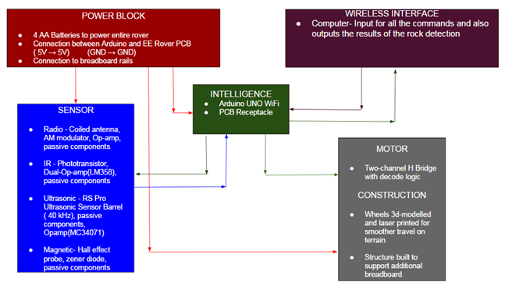

*Figure 1. High level design*

As shown, each block has been addressed in great detail providing the necessary information within them. A 5V battery source is used to power the individual sensors, Arduino and motor. The connections specified in the diagram can be applied to the Arduino, PCB and breadboard.

Another essential block is the ‘Intelligence unit’; it controls the entire operation of the sensor and motor unit. It mainly consists of the Arduino unit (for the sensor) and the PCB unit (for the motor) with some interconnection present between other units. For more detail on the code and the data processing/capture, please refer to part 2.

The next block is the sensor block and this block essentially captures the physical data. Each unit, eg.radio, is a different circuit implemented on a breadboard and the details are listed in part 2. This block is responsible for acquiring instructions from the intelligence and also transmitting physical data back to the Arduino for data processing.

The physical movement and construction of the rover is governed by the motor and construction block. The motor utilised is the same as the one on the EE Bug however, the construction of the chassis and wheels have been altered to suit the terrain.

Finally, the interface block connects to the intelligence and is responsible for sending instructions to the Arduino which then relays those instructions to the relative blocks. Moreover, we have designed our interface in such a way that the results are also displayed on the interface and during each measurement, the Arduino does the data processing and determines the rock.

**2. Design Process**

**2.1 Concept Generation**

In order to generate different ideas as a group, multiple concept generation techniques were explored. These included brainstorming, mind maps and concept matrices. Figure 2 is one example of a result from a brainstorming session in which ideas regarding the motion of the rover were discussed.

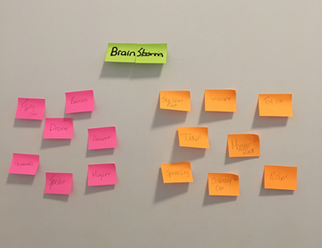

*Figure 2. Brainstorm*

Team members came up with different ideas which were then colour co-ordinated. The pink post-it notes apply to a flying rover, for example hovercrafts, drones, helicopters, etc. The orange post-it notes correspond to a ‘land’ rover design: monster trucks, tanks, spider robots, etc. Although some ideas were far-fetched and slightly unrealistic, it was an engaging process that motivated each member to generate creative ideas.

Once the group decided to implement a ‘land’ rover, a discussion took place on the different types of wheels that could be used, via a mind map.

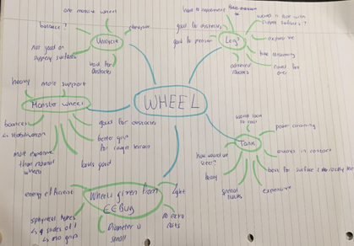

*Figure 3. Mind map produced during concept generation*

Different wheel concepts were analysed: a unicycle, robotic legs, tank tracks, monster truck wheels and the wheels provided from the EEBug. The advantages and disadvantages of each option were explored and the monster truck wheels were voted as the best option. Although more expensive than other wheels, monster truck wheels give our rover more stability, better grip and make it more aesthetically pleasing.

**2.2 Concept Selection**

The process of concept selection follows on directly from concept generation. This method was utilised to ensure the input of every group member was treated evenly. Each sensor subsystem had to go through this process but only the infrared sensor will be outlined in detail.

The first step is to eliminate or combine incomplete ideas to form a complete matrix. Some of the post-it notes had ideas which were not possible such as using the Arduino ADC and were immediately eliminated. Other ideas such as high and low pass filters and selective amplification were combined to give the Twin-T filter. Our method of concept generation involves using post-it notes and by grouping these into categories, three matrixes were formed, as shown in Figure 4.

*Figure 4.1 Idea 1 prepared as a matrix* *Figure 4.2 Idea 2 prepared as a matrix* 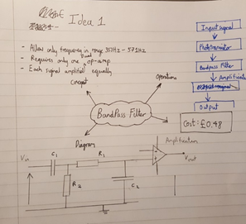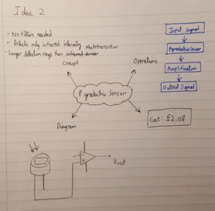

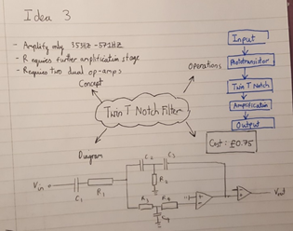

*Figure 4.3 Idea 3 Prepared as a matrix*

Each matrix is based on a mind map with the concept in the middle followed by four categories to ensure that every group member understands the concept proposed. The concept briefly explains the main features of the matrix whilst the block diagrams give an intuitive explanation of the operations. The circuit gives a visual representation to accompany the block diagrams. In each diagram, the components do not have values labelled as specific details such as gain and bandwidth are to be specified when the design is finalised.

The next step was to come up with the selection criteria to be used to evaluate each concept. The basis for the selection criteria was the PDS as these represented the core features the subsystem must fulfil. However, each point (e.g. performance) had to be made specific to the sensor as opposed to the whole rover; such as range, quality of output etc. (See Column 1 of Figure 5).

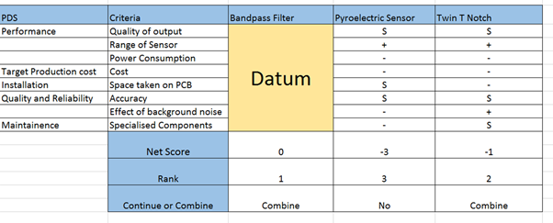*Figure 5. Results of concept selection matrix*

The Twin T filter has a complex circuitry and transfer function while the pyroelectric sensor was simplistic since it used the IRA-E710ST0, which is an off-the-shelf component. The bypass filter is used as a datum since it is in the middle of these two extremes and works as a benchmark.

The quantitative criteria, such as cost, was immediately obvious. However, there were debates on other criteria such as accuracy and quality of output. Decision making was based on majority voting. As the team compared the datum against the criteria, members realized the benefits of selecting a concept which already exists as a datum. In hindsight, the pyroelectric sensor would be the preferred datum as criteria such as range of sensor can be referenced to the data sheet.

The results justified the decision to eliminate the pyroelectric concept, however, it was harder to distinguish between the datum concept and the Twin Notch Filter circuit since both were separated by a score of 1. Finally the group decided that it would be feasible to combine both concepts together. The team decided to merge these two concepts by identifying the drawbacks of the Twin T Notch Filter which were

1 .Power Consumption

2. Cost

3. Space on the PCB

Discussion among the group concluded that these three drawbacks arise from the fact that the circuit utilises an additional Op-Amp to create two circuits with different resonant frequencies. If these were eliminated, the score for the matrix would rise to 2. Working towards the solution involved making compromises namely using one circuit with resonant frequency equal to the mean of the two infrared signal. This concept was suggested as the Twin T Filter behaves like a bandpass filter since the gain decreases as frequency diverges from resonant frequency (see Figure 6). This was the benefit when both concepts were combined.

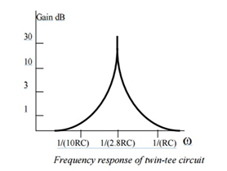

*Figure 6. Frequency response of a Twin-T filter*[1]

The Gain decreases on either side of the resonant frequency and behaves like a band pass filter in the bandwidth of the Twin T. However, frequencies beyond the band will also be amplified but to a negligible amount.

**2.3 Simulations**

The concept produced from the Concept Selection Matrix may be innovative yet, more research must be conducted to implement the circuit. Before, components were purchased for each sensor, the circuit was put through a simulation using circuit wizard.

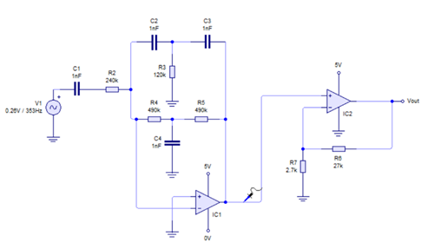

*Figure 7. A test circuit with a small infrared signal with frequency 353Hz as input*

One concern of implementing the Twin T Circuit was the gain at both frequency will be less than 1 but this was easily tested using Circuit Wizard (Results for test done with Figure 7 shown in Figure 8 and 9)

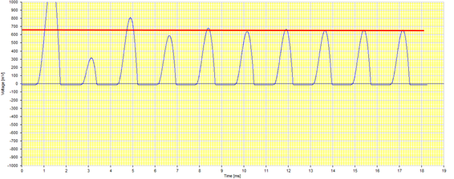

*Figure 8. The trace is the potential measured by the blue probe in Figure 7. The input signal is 260mV and the measured output is 650mV giving a gain of ×2.5.*

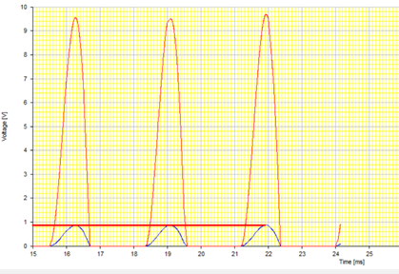

*Figure 9. Results for test done with configuration Figure.7 but with the signal frequency changed to 571Hz.*

The trace in Figure 9 shows the potential measured by the blue probe in Figure 7. The input signal is 260mV and the measured output is 860mV giving a gain of ×3.3 .The red trace shows the amplified signal after the ×11 amplification by the non-inverting amplifier.

The circuit simulation was a useful tool in ensuring the circuit works before the components were ordered. This reduced unnecessary cost of ordering surplus components. In this instance, the simulation made us realize that the gain of Twin-T filter alone was insufficient and that another non-inverting op amp needed to be connected in series to get gain of 3.55×10 = 35.55. If the simulation was not done, there would be a bottleneck when members had to wait to order an additional op-amp.

**2.4 Critical Analysis**

Whilst working on the sensors, the group went through a constant cycle of implementing, improving and re-implementing circuitry in order to make it functional. Listed below, for all the sensors, are some procedures that the group took in order to overcome these hurdles:

* The magnetic sensor had a DC offset voltage even without a magnet. Therefore, the group had to eliminate it using a zener diode, however, the voltage drop was not big enough across the zener diode to remove the DC offset. The team therefore needed to utilise an appropriate resistor between the diode and ground. The value of the resistor was determined through calculations involving the resistance of non-ideal components. Eventually, the rover was able to detect both the north and south poles of the magnet, which was important as the criteria required us to be able to.
* The acoustic sensor required amplification as the signal was too weak to detect. Initially, the amplification did not work as the resistor values were too low. In addition to this, when undergoing inverting amplification, the system did not allow for negative voltages, which resulted in losing the signal. In order to overcome these issues, the group set V+ at 2.5V and used higher value resistors.
* The infrared sensor needed amplification as the infrared signal has a very small intensity. The rover was receiving values of the magnitude of a volt before we selectively amplified the signal frequency. Amplifying the signal required a Twin T Notch lay out, although it could have been done by constructing two separate circuits for the two signals, one was sufficient by setting the resonant frequency to the average value of the two signals.
* The radio signals were too weak to detect, especially if the Exorock was not directed at the centre of the antenna. Therefore, to increase the reliability of our antenna the group increased the diameter of the air-cored antenna to maximise magnetic flux going through it. Moreover, initially we used one op-amp with a gain of 30. However, due to the gain bandwidth limitation, the signal was being distorted. Therefore, two amplifiers in series with a smaller gain which results in squaring the gain and ensures accuracy.

**3. Project Management**

**3.1 Planning**

The main objective for this term was to design and prototype the rover. To achieve this goal, management roles and technical parts of the rover were allocated to each member of the team. Before the presentation, the group was split into two main groups: three members worked on the hardware, including the sensors and motor, whereas the other half worked on the Arduino, Wi-Fi interface and the overall software structure.

After the presentation, the roles were split up more specifically to allow each member to work on the designated part individually. Since the sensors were integral parts of the project, the group dedicated most of our time to produce the respective circuitry for each sensor plus a general idea of the code. One member then programmed the Arduino, with the Wi-Fi interface, to allow the computer to output the correct rock. The roles for each member are listed below:

Subakrish: Infrared sensor

Kaiyue and Yasmin: Radio sensor

Prithvi and Sung Hoon: Motor, Magnetic and Ultrasonic sensor

Pedro: Arduino and the Wi-Fi interface.

Prior to ordering the components, computer simulations were conducted in order to check the validity of certain circuits and to help us choose only the essential components. After running through the simulations, the sensors and electrical components were ordered through labweb. With the Exorock provided, the sensors were then tested physically and modified to overcome real life limitations. Through continuous failure modification, the respective final designs were produced. The output for each sensor circuit was then fed into the inputs of the Arduino and respective data processing methods were conducted in order to determine each rock.

Meeting structure remained unchanged since the presentation with at least an hour a week to discuss investigations on individual parts and progress since last week. During the rest of the week, members designated individual time to investigate sensors and program the Arduino. The meeting was usually held before electronics lab on Monday and additional sessions were held on Tuesday and Wednesday after lectures. At the end of each meeting, targets were set for each member. This measure was taken to ensure steady and continuous process throughout the term.

*Figure 10. Gantt chart of the project plan*

The final project plan is to refine the design and proceed overall testing for the competition demo near the end of the summer term. Although tyres were ordered for mechanical construction and design, the chassis needs to be refined to maximize its efficiency not only for the motion, but also for detecting the rock. Also, members are planning to find ways to increase the efficiency of each sensor and maximize its range.

**3.2 Budget and Costing**

The budget of the EERover is £50. Our goal is to construct the rover in the most cost-effective way. This meant we had to come up with innovative ideas in order to spend as little as possible. Below are the bills of materials tables, BOM, which include the bill of every component within our EERover.

***EEBug Components:***

|  |  |  |
| --- | --- | --- |
| Component | Quantity | Cost |
| Chassis | 1 | 2.00 |
| Motor | 2 | 2.24 |
| Battery Holder | 1 | 1.02 |
| 1.5V Cell | 4 | 0.96 |
| Breadboard | 2 | 5.76 |
| Main PCB | 1 | 2.71 |
| Main PCB components | 1 set | 1.74 |
| Motor Driver | 1 | 5.33 |
| Arduino Uno Wi-Fi | 1 | 25.20 |
| Total |  | 46.96 |

The EEBug expenses do not come out of our budget. The total cost of the EEBug components is £46.96.

***EERover additional components:***

|  |  |  |  |  |
| --- | --- | --- | --- | --- |
| Component | Value | Quantity | Tolerance | Percentage of Budget |
| Ultrasonic Sensor | 710224 | 1 | 2.43 | 9.70 |
| Hall Effect Sensor | 2SS52M | 1 | 2.21 | 8.84 |
| Phototransistor | SFH300-3/4 | 1 | 3.42 | 0.544 |
| Op-Amp | LM358PE4 | 1 | 3 | 1.96 |
| Op-Amp | MC34074PG | 1 | 3 | 3.92 |
| Wheel | ------ | 2 | ----- | 0 |
| Tyres | ------ | 2 | ----- | 4.56 |
| Total |  |  |  | 39.23 |

***Components supplied in labs:***

|  |  |  |  |  |
| --- | --- | --- | --- | --- |
| Component | Value | Quantity | Tolerance | Cost(£) |
| Resistor | 820 | 1 | 1 | 0.05 |
| Resistor | 2.7k | 1 | 1 | 0.05 |
| Resistor | 10k | 6 | 1 | 0.36 |
| Resistor | 16k | 2 | 1 | 0.10 |
| Resistor | 27k | 1 | 1 | 0.05 |
| Resistor | 37k | 1 | 1 | 0.03 |
| Resistor | 100k | 7 | 1 | 0.21 |
| Resistor | 120k | 1 | 1 | 0.03 |
| Resistor | 240k | 1 | 1 | 0.04 |
| Resistor | 490k | 2 | 1 | 0.06 |
| Capacitor | 1nf | 4 | 1 | 0.40 |
| Capacitor | **1µf** | 4 | 1 | 3.28 |
| Inductor | 6.7µH | 1 | 1 | 0 |
| Zener Diode | 3V | 1 | 2 | 0.26 |
| Diode | IN4148 | 1 | 2 | 0.01 |
| Total |  |  |  | 4.93 |

Total Expenditure: £20.00

Total cost of rover : 71.89

**Part 2**

**4. Sensor Design**

**4.1 Radio Sensor**

The Exorock emits four types of radio waves:

1. 61kHz radio modulated at 113Hz
2. 61kHz radio modulated at 181Hz
3. 89kHz radio modulated at 79.0Hz
4. 89kHz radio modulated at 139Hz

In order to receive radio signals, we used a tuned coil antenna: an air-cored inductor, made of solid core wire, with average diameter of 7.75cm. The Exorock produces magnetic flux and the large diameter ensures as much flux to go through it as possible. The voltage of the signal received by antenna can be increased by connecting the inductor in parallel with a capacitor to form a resonant capacitor-inductor (CL) circuit, with one node grounded. When the impedance of the capacitor and the inductor are equal in magnitude and opposite in direction, the current through each component is maximized so that voltage at the other node is maximized. This is where the circuit will be most sensitive.

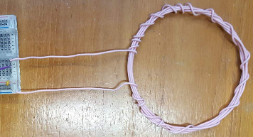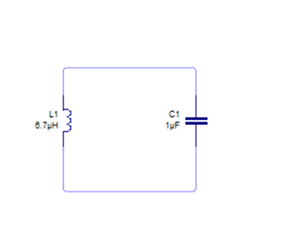

*Figure 11. Antenna Figure 12. CL resonant circuit*

Figure 11 shows the antenna and Figure 12 shows the resonant circuit with a 1F capacitor and a 6.7H inductor used within radio sensor. The resonant frequency of this circuit is approximately 61 kHz, which is the carrier frequency, fc, of two of the possible radio waves emitted by the rock. We tested this circuit with both possible carrier frequencies and found that it picked them both up reasonably well. The signal amplitude received by this antenna was about 30 mV for the 61 kHz signal and 20mV for the 89 kHz. Therefore, instead of having two separate circuits for each carrier frequency, we can use just one which saves money, power, space and weight. However, these amplitudes are much too small to be detected accurately. 1~3 volts amplitude is reasonable and can be detected properly which means the amplitude should be amplified ×30~100. This was done using operational amplifier.

The circuit is limited to work under a single +5V power supply. This left us with two options:

* A circuit that uses a single op-amp with a small signal gain in the range of 30~100.
* A circuit that uses two op-amps each with a gain of 10; placing them in series achieves a total gain of 100 (10x10).

The gain bandwidth product (GBP) of the op-amp is a limitation of the DC gain; exceeding this limit can cause signal distortion. Therefore, the second option is preferred as it allows us to achieve a high gain overall without having a high gain bandwidth product. In this case, we require a minimum GBP of 890 kHz.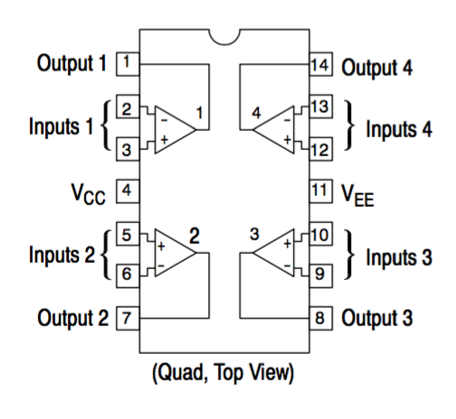

*Figure 13. MC34074* [2]

Fig. 13 shows the device MC34074PG which is able to meet the requirements as the op-amp chip. As shown above, there are in fact four op-amps built onto the chip.

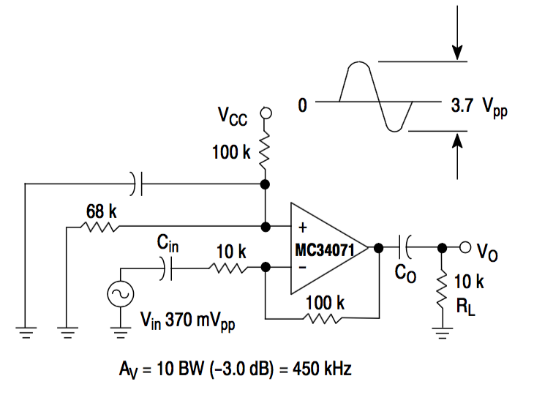

*Figure 14. AC coupled inverting amplifier* [2]

Figure 14 shows a typical single application with Vcc (power-supply pin) = 5.0V. This circuit works as an AC coupled inverting amplifier. The gain is set to 10 by connecting a 10kΩ resistor at the negative input (v- ) and a 100kΩ resistor through the negative feedback loop. The product of the DC gain and bandwidth should not exceed the GBP of the op-amp.

The Arduino microcontroller will struggle to sample the radio signal at its carrier frequency and so we designed a circuit that performs envelope detection in order to produce a signal which indicates the amplitude of the signal. First step is rectification.

Rectification is achieved by inserting a diode into the circuit, resulting in the removal of the negative part of the amplified signal. However, the diode needs about 0.7V in order to turn on, and so, we designed our op-amp circuit to add a 0.7 DC voltage onto the signal. This is implemented via a potential divider; connecting a 100 kΩ resistor between positive input (V+) and Vcc, and a 16kΩ between V+ and ground. Deduction is shown below.

V+

We require a DC voltage at the output and so the capacitor Co (Figure 14) at output stage has been removed in our circuit. The capacitor between V+ and ground is not necessary as the DC voltage supply is stable. The incoming signal is not completely AC coupled so Cin cannot be ignored. Our final op-amp circuit is shown below in Figure 15.

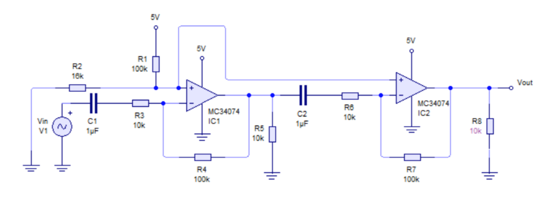

*Figure 15. The complete op-amp circuit*

During envelope detection, the diode rectifies the amplified signal. After this, a capacitor and a resistor are connected in parallel to eliminate the carrier frequency whilst conserving the modulated frequency, fm.

The voltage across the capacitor is time dependent as it discharges through the resistor. It can be found using Kirchhoff’s Current Law where the current through the resistor must equal the current charging the capacitor, giving:

,where C is the capacitance of the capacitor.

Solving this equation for V gives us an exponential decay formula:

*V0* where Vo is the capacitor’s voltage at time t =0.

The product RC must be much greater than the reciprocal of the angular fc, and smaller than the reciprocal of the angular fm.

,

.

To satisfy these equations, our circuit uses a 1µF capacitor and an 820Ω resistor.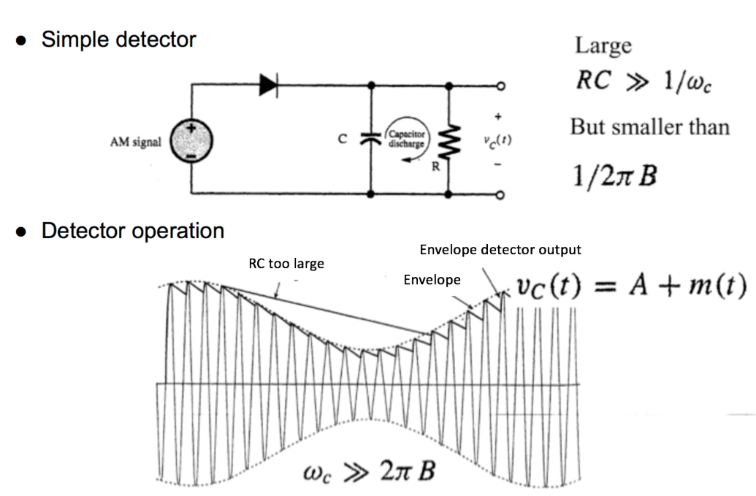

*Figure 16. Envelope detection* [3]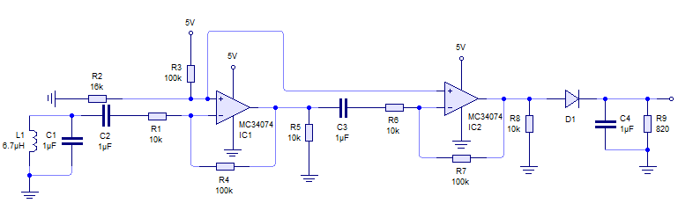

*Figure 17. The complete radio sensor*

This is the final circuit for our radio sensor including the antenna, the op-amp circuit and the envelope detection circuit. Taking the 61 kHz radio signal modulated at 113 Hz as an example, Figure 18, 19 and 20 illustrate some of the experimental data we have gathered.

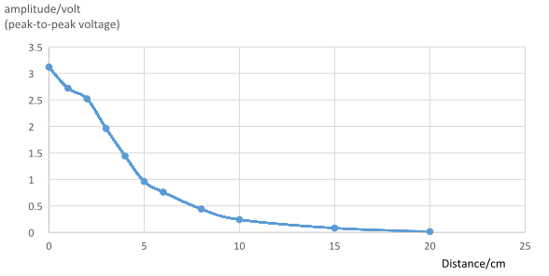

*Figure 18. Graph showing amplitude vs Vertical distance*

Figure 18 shows how the amplitude of signal changes as the distance of the Exorock increases from sensor when moved vertically above it. Apparently, as the vertical distance increases, the amplitude decreases. 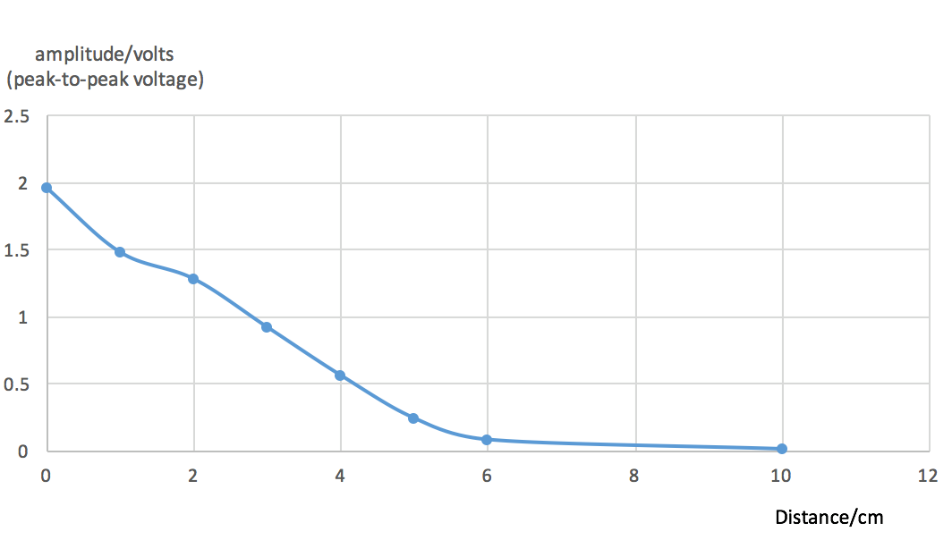

*Figure 19. Amplitude vs Horizontal distance*

Figure 19 shows how the amplitude of the signal varies as the rock is moved horizontally from the sensor with the antenna 3cm above the rock. As the horizontal distance increases, the amplitude decreases.

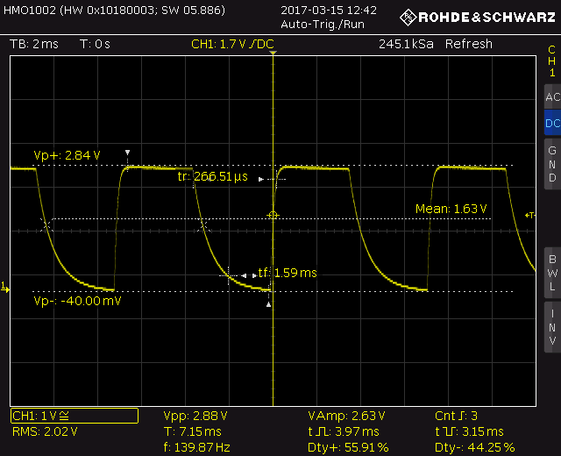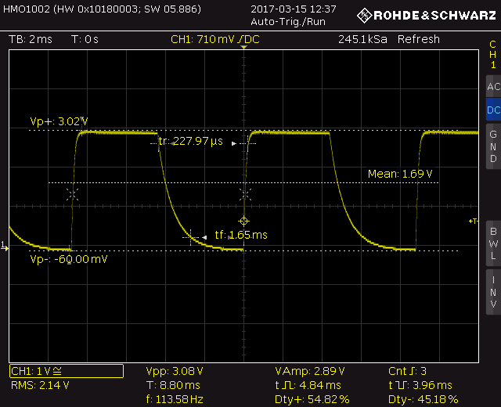

*Figure 20. Figure 21.*

Figure 20 shows the output signal of the circuit whilst the Exorock was at a zero distance from the sensor; we measured a value of peak to peak voltage 3.08V. Fig. 21 shows the output signal of 89 kHz radio modulated at 139Hz with peak to peak voltage 3.02V, proving that our first stage resonant circuit works for this carrier frequency as well.

**4.2 Acoustic Sensor**

In order to detect the ultrasonic signal, the group decided to implement an acoustic sensor. The acoustic sensor that was implemented was the RS Pro Ultrasonic Barrel as this sensor was most sensitive at 40 kHz, the frequency the Exorock emitted.

Our initial test was conducted without any additional circuitry in order to determine the amplification required. Therefore, the waveforms obtained with only the sensor is shown below:

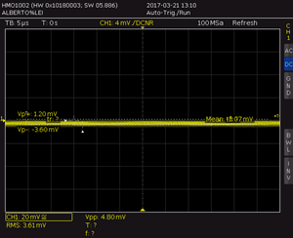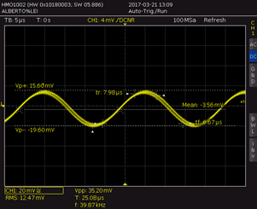

*Figure 22. Acoustic signal prior to amplification*

The second waveform shows the acoustic signal as a sinusoidal wave of 35.8 mV (Vp-p). This was obtained when the rock was placed upside down and the sensor was very close to the source. During the final experiment, as the rock would be at a certain distance and upright, the group also conducted a second measurement and obtained the first waveform, which indicates that the signal was not readable. Therefore, for the Arduino to be able to detect the signal, the team decided to amplify the small signal with a gain of ×100. In order to do this, a single op-amp with a gain of ×100 or a dual op-amp with a gain of ×10 would be required. In order to be cost effective and maximise space on the breadboard, the group decided to use the remaining two op-amps from the device used for the radio sensor. The GBP for this op-amp was 4.5 MHz and a single amplification of ×100 would have been possible as the 40 kHz frequency of the wave was lower than the 45 kHz limit for an amplification of 100. However, this would leave an op-amp unused and could affect the offset voltage of our signal. Instead of minimising this effect by setting the unused op-amp as a voltage follower, the group decided to divide the amplification into ×10 and ×10 and utilise both op-amps. Our initial circuit is shown below:

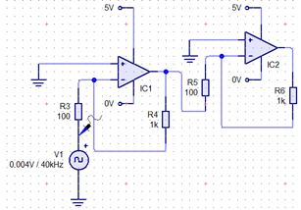

*Figure 23. Initial amplification unit*

Overall, even though the group decided to utilise an inverting amplifier, the output wave would not be affected as 2 inversions would result in the original orientation being produced. Initially, the V+ terminal of the op-amps were grounded so that a differential input could be achieved but after conducting a few tests, we realised that we would lose half of the signal as anything below 0V would be lost. Additionally, as the positive terminal was grounded, a ‘virtual earth’ would be set up at the negative terminal. By using low impedance resistors of 100Ω and 1kΩ, this setup would start emulating a circuit with the sensor connecting to itself with a low value resistor (show below).

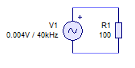

*Figure 24. Short circuit with small resistance*

Therefore, the team decided to set V+ at 2.5V (using a 100kΩ potential divider circuit) so that the entire signal was amplified. The signal from the sensor was then fed into the negative terminal and 100kΩ and 10kΩ resistors were used. With the mentioned improvements, the final circuit was implemented:

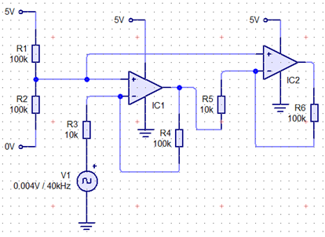

*Figure 25. Final circuit*

This led to the below waveform being produced:

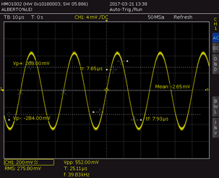

*Figure 26. Waveform with amplification*

As seen above, the wave obtained after amplification was around ×100 and did not exhibit cross distortion. The frequency measured was 39.83 kHz, which correlated to the 40 kHz frequency stated in the guide.

**4.3 Infrared**

The Sensor design is based on a Phototransistor (SFH300-3/4) connected in series with a 10kΩ resistor. This design utilises the current-luminance characteristics of the phototransistor which determines the voltage drop across the resistor and thus the variation in the potential at point Vin. The first input stage in Figure 27 should ideally provide a digital signal with a high voltage (5V) when the infrared intensity is infinitesimally small and a low voltage (0V) when the intensity is infinite. However, the interference of ambient visible light affecting the luminance of the phototransistor requires stage 2 which selectively amplifies the infrared signal and effectively filters out other sources of illumination. Finally, stage 3 uses a non-inverting amplifier to amplify the signal to increase the range of the infrared sensor.

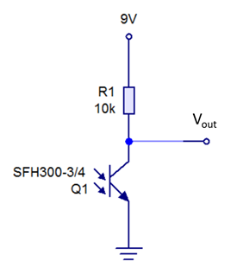 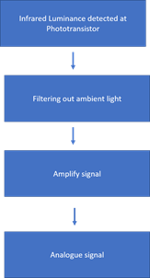

*Figure 27. Input stage of the sensor Figure 28. Block diagram for the sensor*

Resistor R1 shown in Figure 27 determines the sensitivity of the infrared sensor as a large value of R1 results in a large variation in Vout for small changes in infrared intensity [4]. A 10kΩ resistor for R1 allows for the whole spectrum of 0-5V to be used effectively. Another important part to take into consideration is the current-luminance characteristics. The Photocurrent of the SFH300-3/4 is dependent on the irradiance of light, between 400-1100 nm, that is incident on the Phototransistor. Therefore, ambient light (Visible light in the range of 300nm-700nm) as well as infrared (>700 nm) will induce a photocurrent. As indicated by the spectral sensitivity in Figure 29 from the data sheet, visible light has a high spectral sensitivity and high intensity compared to the infrared signal with lower intensity. Hence, the amplifier stage is necessary in order to selectively amplify the frequency of the signal. A bandpass filter followed by an amplifier would also work but using a Twin-T filter would reduce passive components needed to bias the op-amp and construct the filter.

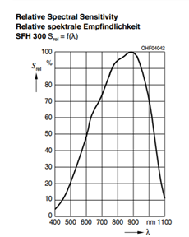

*Figure 29. Data sheet of the SFH300-¾* [5]

The frequency of the two infrared signals are 353Hz and 571 Hz respectively and amplifying this frequency ensures a significantly higher gain. The Twin-T filter is biased shown in Figure 29 and notably has a peak gain of magnitude 83.51dB [4] at a resonant frequency of 468.9Hz.

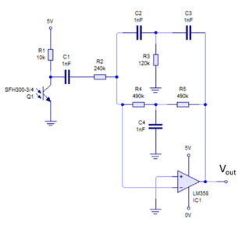

*Figure 30. Biasing configuration of the Twin-T filter connected to the input stage*

The resonant frequency is selected to be 468.9 Hz instead of 462 Hz, which is the mean of the two signals, but it was not possible to construct a circuit with the latter resonant frequency using standard resistor and capacitor values. The use of just one Twin-T filter is an engineering trade-off as the signal frequency and resonant frequency is not matched but it is more cost-effective and saves space on the breadboard.

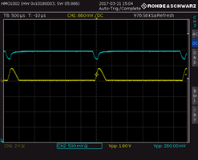

*Figure 31. CH2 directly shows the Potential across the Phototransistor (value shifted down 4V). CH1 displays the output of the Twin T Notch for the 571Hz signal.*

Before the final amplification stage, the signal is shown in Figure 31 and is around 260 mv which is when the phototransistor was 1 cm from the rock. To increase the range of the sensor, the output is directed into another inverting amplifier with a gain of ×11 (see Figure 32) and the output signal is shown in Figure 33, 34 and 35. The circuit for the whole sensor is in Figure 36.

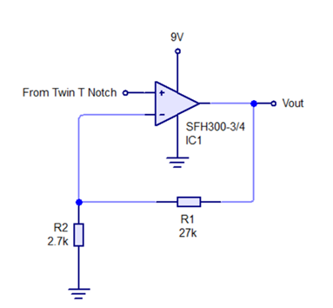

*Figure 32. Amplification stage*

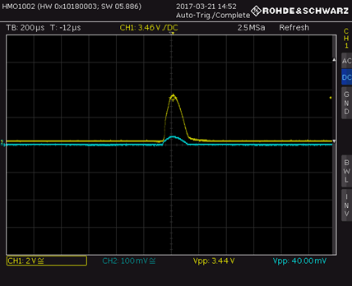

*Figure 33. CH1 Output of non-inverting amplifier and CH2 is the non-inverting input*

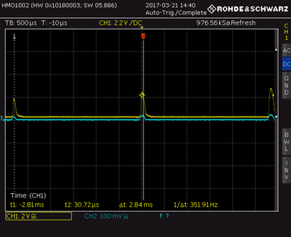

*Figure 34. CH1 is the Vout of the 353 Hz signal and then using cursor measure to obtain the frequency which is 351.91Hz*

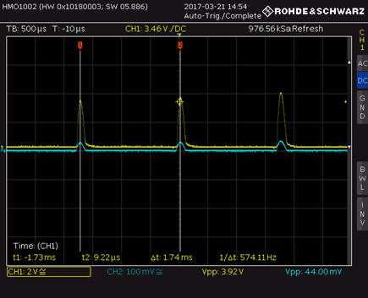

*Figure 35. CH1 is the Vout of the 571 Hz signal and then using cursor measure to obtain the frequency which is 574.11Hz*

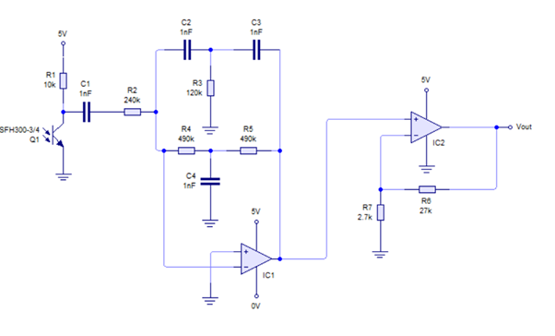

*Figure 36. Complete Circuit*

In terms of reliability of detecting 571 Hz infrared, the frequency of the detected signal is 574.11Hz compared to the stated 571 Hz which gives a percentage error of 0.54 % and ensures the two different signals can be identified correctly.

%Error = Actual frequency – Detected Frequency

Actual Frequency

= (574.11-571)/571×100

=0.54%

On the other hand, the percentage error for the 353 Hz is -0.31%. The distortion of the signal from a square wave into a half-wave sine wave is due to the different frequency components of the square wave (each having different Fourier coefficients) being amplified by different amounts. However, the algorithm on our Arduino is able to determine the frequency of this sine-wave.

**4.4 Magnetic Sensor**

A Hall Effect sensor was implemented in the rover to detect the static magnetic field produced by the Exorock. Although a coil of wire could be used to detect the field, current would not be induced unless the coil is moving. This could be done by attaching a coil of wires to a motor. However, this design choice was not adopted considering the limited space of the breadboard and the danger that three motors (motor for the left wheel, right wheel and the coil) might draw too much current from the four 1.25V batteries. Ultimately, the SS496A1 Hall Effect Sensor was used because of its small size and high energy efficiency of 7 mA and 5VDC [6], which the batteries from the EEbug can supply.

Hall Effect sensors use the basic principle that magnetic fields exert force on moving charged particles. By supplying voltage through a p-type semiconductor, a constant current would be generated and would result in a movement of charged particles. If a magnet is placed near the sensor, the magnetic flux would move the charged particles perpendicular to the current, thus creating a potential difference inside the semiconductor. This potential difference is then amplified to give a DC voltage to the output terminal depending on the strength of the magnetic field [7]. The diagram below shows the input terminals for Vcc, ground and the output terminal.

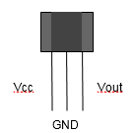

*Figure 37. Diagram of a Hall Effect sensor*

The Hall Effect sensor was tested out by connecting Vcc to 5 volts, GND to 0 volts and Vout to an oscilloscope. A 10 kΩ resistor was used to connect between Vout and Vcc. When no magnet was present, the sensor gave a constant voltage of 2.26 V.

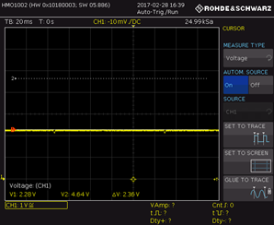

*Figure 38. Vout of the Hall Effect sensor without a magnet*

Then, a magnet was placed in proximity to the Hall Effect sensor. When one side (for future purposes this is called the “north” pole) of the magnet was placed near the sensor, the voltage increased to 4.38 volts. When the other side (“south” pole) was facing the sensor, the voltage decreased to 25.95 mV. The figure below shows the oscilloscope screenshot of when the north and the south pole of the magnet was facing the sensor respectively.

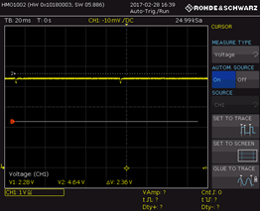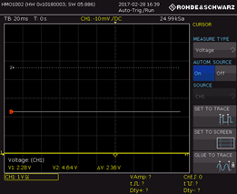

*Figure 39. Vout of the Hall Effect sensor with north and south pole of a magnet*

Since the voltage of the output terminal does not change with respect to time, Vout can be connected directly to the digital pins of the Arduino. However, there is a problem with the current circuit. The Arduino will address south pole as 0 or the low state since the voltage is in millivolts and relatively low compared to the north pole or when there is no magnet present. However, the Arduino will address both north pole and no magnet as a high state since the output voltages for both states are significantly higher than the south pole. This means that the sensor will only be able to distinguish south pole from the other two states. When the north side of the magnet is facing the sensor, the Arduino will not be able to determine whether if there is a magnetic field present in the rock.

To solve this problem, a zener diode circuit or a comparator could have been used. The zener diode option was implemented as it offered a compact, cost-effective and simplistic solution to the problem; a comparator would require complicated circuitry and would put more pressure on the budget. Zener diodes are similar to regular diodes but have a breakdown voltage which allows the current to flow in reverse direction when the chosen voltage exceeds the breakdown voltage, making it suitable for this problem. If a zener diode with a breakdown voltage of 3V was chosen, the output voltage for the south pole and no magnet will be blocked while the output voltage for the north pole would be passed through. By connecting the output, filtered through the zener diode (V2), to the digital pin of the Arduino along with the non-filtered Vout (V1), all states can be distinguished. The table below shows the truth table for Vout with and without a zener diode.

|  |  |  |
| --- | --- | --- |
| Non filtered Vout (V1) | Vout filtered with a Zener Diode (V2) | State |
| 0 | 0 | South |
| 0 | 1 | X |
| 1 | 0 | No magnet |
| 1 | 1 | North |

For there to be a sufficient voltage drop in the zener diode, a suitable current needs to be allowed to flow through it. This is done by connecting one end of the zener diode to the ground with a resistor in between. However, since the diode in the circuit is a non-ideal diode, if a resistor with a very low resistance value (e.g. 100 Ω) is chosen, current will still flow through when there is no magnet because 2.26V is close to the breakdown voltage. However, if the resistance value is too high (e.g. 100 kΩ), the voltage drop would not be significant enough to distinguish between north pole and no magnet. Thus, through trial and error, 39 kΩ resistor was chosen.

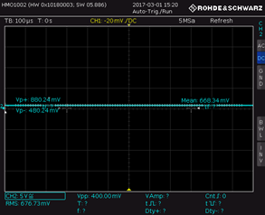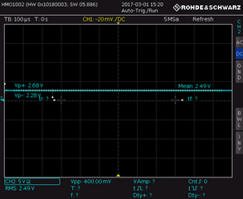*Figure 40. Vout through the zener diode with no magnet and north pole respectively*

The images above show that output voltage through the zener diode is 668.34 mV when there is no presence of a magnet and 2.49 volts when the north pole is facing the sensor. This was correctly registered in the Arduino as low state and high state respectively. Therefore, the final circuit diagram for the magnetic sensor is shown below.

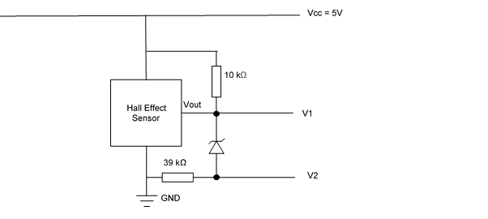

*Figure 41. Final circuit diagram for the magnetic sensor*

**5. Mechanical Design**

**5.1 Wheels**

In order to ensure a smoother locomotion, adapted to the environment, the group decided to modify the wheels. In order to do this the team initiated a brainstorming session (seen in part 1) and from this, chose one design which members modified and implemented.

In terms of a general design, we decided to go with the ‘monster wheel’ design as we thought that this design was the most apt for the environment. In reality, monster wheels are used to function in rocky terrain and have a very solid base which prevents the vehicle from tipping over. However, we did make some modifications and the overall, the design below was implemented:

*Figure 42. Wheel Design*

The dimensions of the wheel are approximately 73mm (diameter) by 17mm (width) because it needs to fit into the tyres that the group bought. Since our options for the tyre were highly limited, the group based the tyre’s dimensions mainly on this criteria. Moreover, our motor was being powered by the same 5V battery source which powers all the additional circuitry so if we were to have bigger wheels, these would require more power to rotate and would put unnecessary strain on the power supply. Moreover, we decided to emulate the design of tyres used in vehicles (not going for a solid block of plastic as seen with the basic tyres) for a few reasons. Firstly this would require more unnecessary material to be printed, increasing our cost. Moreover, with solid tyres, the movement would be less smooth as vibrations would affect the circuitry and if it vibrates too much, certain components could get dislodged and stop the sensors from working.

In terms of the rubber casing outside, the group decided to utilise one with a width of 20mm as this would ensure smooth travel. The spikes would also add additional grip and help the rover traverse over obstacles. The rubber casing utilised is shown below:

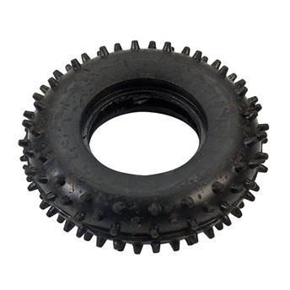

*Figure 43. Tyre design* [8]

To put everything together, the team decided to print the wheel and fit it into the tyre as other ways, eg. Cutting the tyre open and sticking it, could result in indentations that could affect the motion.

**6. Interface and Motor**

**6.1 Intelligence and Wi-Fi Interface**

The Arduino is responsible for controlling the motion of the rover and also for processing the information sent from the sensors to determine the mineral it is detecting. The Arduino will contain a database of minerals and their specific radio frequencies, infrared frequencies, ultrasonic and magnetic properties. The information received from the minerals will then be collated and the mineral which shows the closest resemblance to the received data will be the detected mineral. The frequency bandwidth tolerance can be quite large for each mineral property, due to the fact that many other properties will be measured and the information will all be taken into account in determining the mineral. Therefore variations in one property should not affect the detected mineral and also a wide bandwidth ensures that variations in the environment do not affect the reliability of the results unless the conditions are too extreme. An AM signal will be detected, which includes a carrier and modulated wave. We decided to mainly distinguish between the rocks by detecting the presence of signals instead and distinguishing between similar signals. This method provides more reliability in distinguishing between the rocks because the chance of error in distinguishing between similar signals is far greater than in determining the presence of signals.

The Arduino can detect a minimum voltage of around 5 millivolts. Therefore, voltage values lower than this will need to be amplified in order to be read by the Arduino. Noise cancellation will be necessary so that noise is not amplified as well as the signal, however the common mode rejection ratio of our op-amps are quite high (97 dB) so noise should not be amplified much. We used a twin-tee filter circuit with a large gain bandwidth product (GBP) for frequency values close to halfway between 61 and 89 kHz to distinguish between the two infrared signals. Although it may make the signals slightly harder to distinguish since they are both being amplified a lot, it saves room on the Arduino breadboard because only one circuit has to be built to amplify two different signals instead of our initial idea of building separate filter circuits for each different frequency. The GBP is large enough so that the amplified signals have a significant amplitude difference that the Arduino can distinguish between the signals.

Since half of the rocks that emit radio frequencies have other distinguishing properties that can be used to identify them, it is only necessary to distinguish between two different radio frequencies. Therefore, no filter circuits are needed (unless they are needed to remove noise but the circuitry inside the op amp is designed to ignore common mode signals and therefore remove noise so a filter circuit should not be necessary) and the signals only require amplification if the voltages are too low. Our code used the pulseIn function of the arduino to read the frequency since it is far below the maximum frequency that the Arduino can detect. This essentially reads the frequency of the signal by detecting when it is high or low. Although the Arduino will not accurately reproduce the input waveform since the pulseIn function is meant for digital and not analog signals, it will still be able to detect a difference in frequency since the frequency of the input signal reaching a value that the Arduino reads as high will be different for different signals. The serial monitor of our Arduino outputs a value depending on the voltage in the analog input, which depends on the voltage drop across the sensor. Our code works by detecting if the value of the serial monitor value reaches a certain value and then prints out the rock. The algorithm works by mainly using IF loops to output the name of rock if the condition set condition is met. For example, with the first rock, the code is written so that if a magnetic signal is detected, then the name of the first rock is printed out. The way we identify the rocks is by their binary equivalent setting on the Exorock. For example, if the setting is High, Low, Low, Low on the Exorock, we identify it as rock 8.

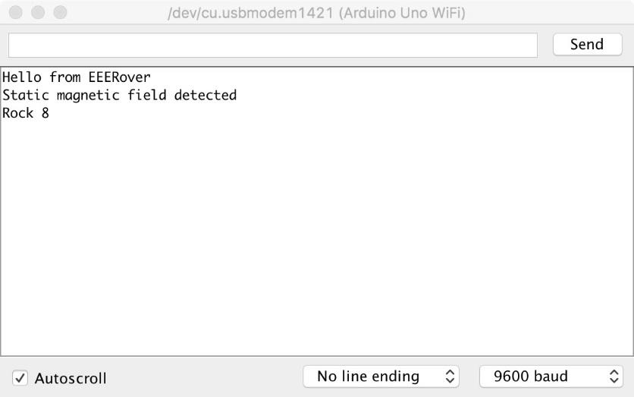

*Figure 44. Example of output when the Arduino receives data that is characteristic of a specific rock*

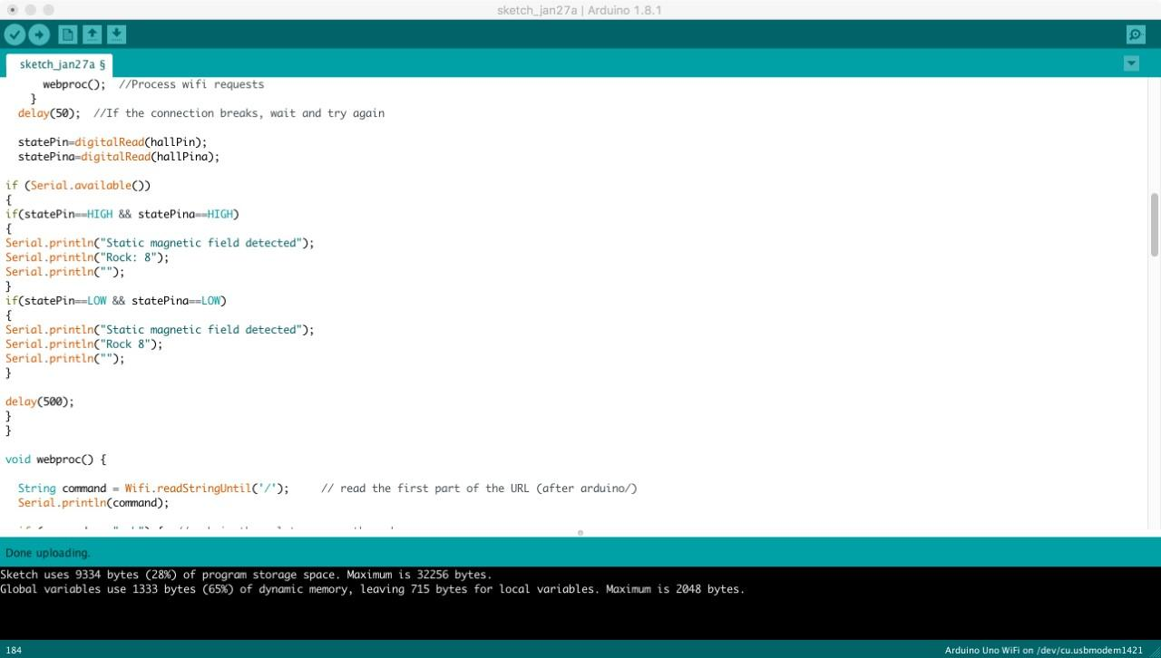

*Figure 45. Code for magnetic sensor*

**6.2 Motor**

In the entire project, the motor was the one aspect that required least modification. With the addition of the H Bridge motor driver, we could control both motors with slight modifications to the code. Each h bridge can take two inputs (pulse width modulation usually 20- 400Hz, DIR) and by controlling 4 low-impedance MOSFETS, it could turn the motor off, make it go forwards or backwards. All 4 movements could be achieved by the using the logic below and different combinations of each respective motor:

|  |  |  |
| --- | --- | --- |
| DIR | PWN | Motor |
| X | 0 | Off |
| 0 | 1 | Forward |
| 1 | 1 | Reverse |

Now, the motor had to be controlled using the Arduino, which could be achieved by inputting the signals into 4 digital pins. Initially, the motor speed was set to a PWM value of 200 (max at 255) and with a void function, initialized the pin directions. Then, with another function called 'movebug', the group implemented the following table to achieve all 4 directions:

|  |  |  |  |
| --- | --- | --- | --- |
| When ↑  LEFT DIR: 1  LEFT PWM: 1  RIGHT DIR: 1  RIGHT PWM: 1 | When ↓  LEFT DIR: 0  LEFT PWM: 1  RIGHT DIR: 0  RIGHT PWM: 1 | When →  LEFT DIR: 0  LEFT PWM: 1  RIGHT DIR: 1  RIGHT PWM: 1 | When ←  LEFT DIR: 1  LEFT PWM: 1  RIGHT DIR: 0  RIGHT PWM: 1 |

In order to control the movement with the user interface, a series of operations under an ‘if’ conditional was implemented so that when the web is accessed, all the essential buttons are displayed. For simplicity, the print function for all 4 directions was used and for ease of control, it was implemented as individual blocks. The basic design is shown below:



*Figure 46. Control panel with the buttons that control the motion of the rover*

In order to change the speed, we could have changed the PWM of the wave in order to change the speed however, after research, we realized that this would require the use of physical buttons/ a potentiometer to change it. As complete wireless control is required, we decided to implement another set of buttons that help increase the duration that the rover is in motion by changing the ‘motorTime’ variable in the code. These functions serve as a user-friendly and reliable way to reduce the number of times that the buttons have to be pressed, making our rover more efficient. The basic layout is shown below:



*Figure 47. Example of the buttons with an increased 'motorTime' variable in the code*

Through the additional buttons, the rover will move in the corresponding direction for a longer period of time.

**7. Conclusion**

Through continuous research and failure modification, the objective to create a rover that identifies different types of rocks in a Mars-like conditions has been achieved. The project began by allocating management roles and brainstorming general ideas of what the design of the rover could be. This was developed further by design processes such as concept generation and concept selection for specific parts of the rover. This included brainstorming and creating mind maps for mechanical construction, Wi-Fi interface and circuitry for each sensors. Then, the different ideas were evaluated using the matrix method and prototypes for each part were created.

Cost and budget was carefully considered when making engineering choices and sensors were checked through software before being bought. Five members of the group were allocated for making circuits for the different sensors and another member in charge of the intelligence. In the end, sensors for detecting radio, acoustic, infrared and magnetic signals were created. Also, the code for the Arduino corresponding to each sensor circuit was programmed.

The overall mechanical construction, such as the tires and chassis, were chosen through design processes. However, the construction could be refined further to increase its locomotive efficiency and detecting the rock. Currently the sensors, except for the radio, are connected in a manner in which its detection surface faces upwards. This could be improved by placing all the sensors to one side of the rover, preferably the north, to maximize its ability to detect the signal. Also, more investigation into the range of detection for each sensors and methods to get rid of background noise could improve the rover even further.

Additional design refinements could be made before the competition demo based on the comments mentioned above. Apart from minor improvements, technical design and prototyping, the only procedures left are overall testing and failure modification.

**References**

(1) Imperial College London. *Operational amplification application*. Available from: <https://intranet.ee.ic.ac.uk/intranet/labweb/pdf/opamp-applications.pdf> [Accessed 10th Feburary]

(2) Onsemiconductor. *MC34074PG Data Sheet.* Available from: <http://docs-europe.electrocomponents.com/webdocs/11a6/0900766b811a656a.pdf> [Accessed 2nd Feburary]

(3) Kin K. Leung. *Introduction to Signals and Communications*. Imperial college London; 2017

(4) MrSirLRD. *Arduino IR Signal Detector*. Available from: <http://www.instructables.com/id/Arduino-IR-signal-detector/?ALLSTEPS> [Accessed 14th February]

(5) OSRAM. *SFH 300 Silicon NPN Phototransistor*. Available from: <http://www.osram-os.com/Graphics/XPic2/00101785_0.pdf> [Accessed 22nd February]

(6) Honeywell. *SS490 Miniature Ratiometric Linear Hall Effect Sensor*. Available from: <http://www.farnell.com/datasheets/1676927.pdf?_ga=1.252222601.1895938363.1489353453> [Accessed 18th February]

(7) Electronics Tutorials. Hall Effect Sensor. Available from: <http://www.electronics-tutorials.ws/electromagnetism/hall-effect.html> [Accessed 23rd February]

(8) Rapid Electronics. *RVFM Small Spiked Rubber Tyre Single*. Available from:

<https://www.rapidonline.com/rvfm-small-spiked-rubber-tyre-single-06-0656> [Accessed 29th January]